Compile XigmasNAS®
This is the easiest way for studying/modify XigmaNAS. It also assumes that the user has an bit of understanding of FreeBSD, including Modify/adding new ports, packages and using the vi text editors.
Start prepare the XigmaNAS® Development Environment.
1. Install FreeBSD XX.X RELEASE.
On a dedicated PC, Within VirtualBox on XigmaNAS system or PC with VMware Workstation Pro/Qemu) installed. (Always match the same FreeBSD version as set in XIGMANAS_GIT_BRANCH="releng/XX.X" in file functions.inc).
The build environment need lesser than 100GB total hard drive space if only setup in a dedicated disk slice for only building XigmaNAS. (More space like 150GB is recommended for active development) You really don’t want to run out of space when building.
When installing FreeBSD create two partitions’, a swap (3.5 GB is a good swap size) and a / partition. Avoid using the A (auto) command to partition the slice. You may get some warnings later about mail security. Since this is a dedicated XigmaNAS build environment only, you can ignore this.
A working networking services with internet access is required to download the source files and ports. You also need to
Hint: If you use the same machine for both a build environment and acting as your XigmaNAS server, use a different IP-address for the build environment from the NAS environment (if you're not using DHCP). This can be done by use bridged adapter in the vm settings. This way if you later SSH into either environment you won’t get warnings about a fingerprint change all the time.
Reboot to complete system install.
You now can login as root.
2. Update FreeBSD
Now, update your installed copy of FreeBSD with the latest patches and delete uncontrolled source files (for proper kernel build), remember this is a FreeBSD Build Only Environment!
2.1. Delete old source files
Delete of the /usr/src directory contents.
# rm -rf /usr/src
# mkdir /usr/src
2.2. Security update
Begin with installing the latest security patches;
# freebsd-update fetch install
2.3. Port update
Install the latest ports source. The first time we use this command:
# portsnap fetch extract

When done you can forward to step 2.4.
Only for subsequent port updates use:
# portsnap fetch update

2.4. Now reboot the system and login as root
Root login is not necessary but really recommend. It’s only the development environment.
3. Install the required ports:
Go into the system ports and make install clean.
# cd /usr/ports/shells/bash
make install clean
# cd /usr/ports/sysutils/cdrtools
make install clean
# cd /usr/ports/ports-mgmt/portupgrade
make install clean
# cd /usr/ports/devel/git
make install clean
# cd /usr/ports/devel/subversion
make install clean
3.1. Download the XigmaNAS source code from SVN.
Now we are ready to create the XigmaNAS directory and grab the source files
3.2. Create the XigmaNAS directory
This is the place where all source files will be stored and it’s scripts can be used.
# mkdir /usr/local/xigmanas
3.3. Fetching the latest XigmaNAS source files
Enter following to get the sources on its right location:

# cd /usr/local/xigmanas
# svn co https://svn.code.sf.net/p/xigmanas/code/trunk svn

(Only registered XigmaNAS developers use: https://svn.code.sf.net/p/xigmanas/code/trunk if they want to upload code to svn)

4. Compile and build XigmaNAS from scratch
Now login as root user and start the compile/build script.
# cd /usr/local/xigmanas/svn/build
# ./make.sh
Note: The ./ in front of make.sh forces the shell to use the file in the current directory, and not search the path for the command.
The following BUILD ENVIROMENT menu should come up and the selections are self-explanatory:

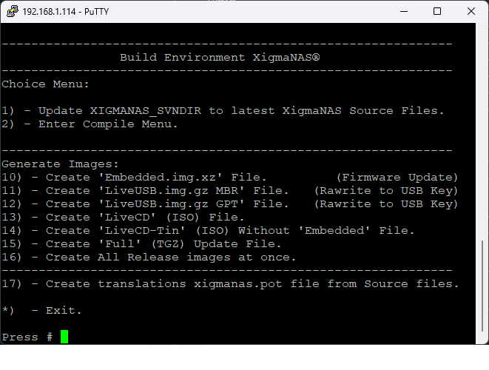
Now press No. 2 to select choice 2 - Enter Compile Menu.
The following BUILD menu should come up and the selections again self-explanatory:
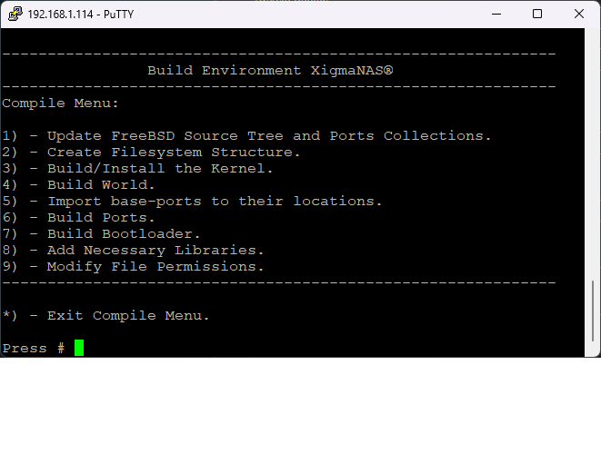Select each menu item in order. (Hint: When it gives you a choice of multiple choices, do one at a time. This way many errors can be corrected/prevented before proceeding.)
When you have compiled the ports in option 6-1 “Build ports” and completed, you do need to compile a second time with 6-3 “Re-build ports” with only ports ports “CA_ROOT_NSS”, ICU and python2” selected. Now finally you’re ready to install 6-4 “Install ports” the compiled ports.
Notes:
· READ the README files in the various svn/build directories
· Kernel patches should be applied only once. Trying multiple times will fail. (see README)
· Building ports can be the most troubling as source locations change, revisions numbers change, etc. So once you get all the ports compiled, you may want to save those locally. Those files are fetched into "/usr/ports/distfiles". Just remember to keep those up-to-date.
· 3 - Build/Install the Kernel. (Second screen has by default all options set!), do not change those options if you don’t know what you are doing! It can cause errors on building/install the kernel!)
When done press * to exit which takes you back to the main menu to select the option(s) for the final product:
10) - Create 'Embedded.img.xz' File. (Firmware Update) (This will create the embedded upgrade file)
11) - Create 'LiveUSB.img.gz MBR' File. (Rawrite to USB Key) (This will create the LiveUSB file and embedded file)
12) - Create 'LiveUSB.img.gz GPT' File. (Rawrite to USB Key)
(This will create the LiveUSB and embedded upgrade file with the checksum files)

13) - Create 'LiveCD' (ISO) File. (This will create theLiveCD and embedded upgrade file with the checksum files)
15) - Create 'Full' (TGZ) Update File. (This will create the full upgrade file for upgrading full install servers)

5. Making a updated translation template for launchpad.
For XigmaNAS® developers only!
XigmaNAS makes use of translations files to display the WebGUI in another language than English.
Only the made xigmanas.pot has to be uploaded svn and launchpad as we only download the translations online from launchpad.
17) - Create translations xigmanas.pot file from Source files.
Hint: Now you are able to locally update a translation. Po with a program like Po edit. Google for it.
Good luck!

